|  |  |  |  |
| --- | --- | --- | --- |
| **F:\Learning bugs\Foundation Subjects\Dolly the Fly - Science.jpgLyng Primary School Knowledge Organiser** | | | |
| **Topic: Forces and magnets** | **Science**  **What are the effect and uses of forces and magnets?** | Year 3 | Autumn 2 |

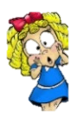

**What should I already know?**

* Children learn how forces effect different materials
* Pushes, pulls, twists and stretches on different objects
* Testing stretchiness- children will explore they ways in which different materials will stretch

Testing the strength of different objects and should be able to identify eco-friendly materials.

|  |  |
| --- | --- |
| **What Step On and Goldilocks words will I use?** | |
| **Spelling** | **Definition** |
| force | Push, pulls and twists in particular directions |
| Contact force | Forces that act between two objects |
| Non-contact force | Forces that act without contact |
| friction | A force that occurs when two surfaces rub together |
| magnetism | A force caused by a magnetic field |
| magnet | An object made out of a magnetic material |
| North pole | One end of a magnet |
| South pole | One end of a magnet |
| Magnetic material | An object that attracts to a magnet |
| Non-magnetic material | An object that does not attract to a magnet |
| attract | Magnets pull towards each other. |
| repel | Magnets push away from each other |
| electromagnetic | Magnetic fields around electric currents |

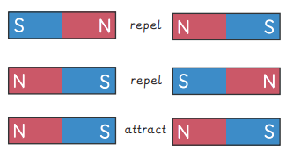

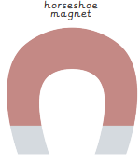

|  |
| --- |
| **Investigate!** |
| Investigate friction!  Does the roughness of a surface effect the amount of friction produced?   * Explore friction on a range of different surfaces * Identify the differences between smooth surfaces and rough surfaces * Explore how these surfaces effect the friction on a moving object. |

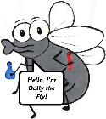

**What will I know by the end of the unit?**

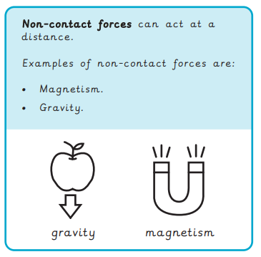

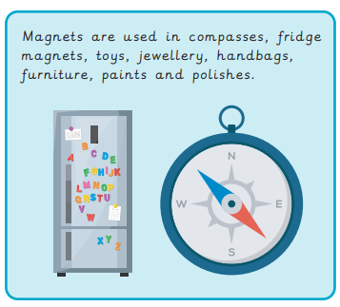

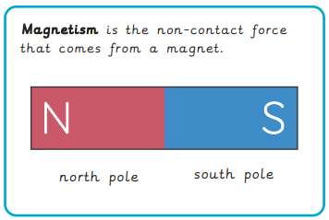

|  |
| --- |
| Our Enquiry Questions |
| * How do contact forces effect objects? * How does friction effect objects? * Why do different surfaces affect friction? * How can we work scientifically to describe the effects of magnets? * How do we know the strength of a magnet? * What are magnets used for? |

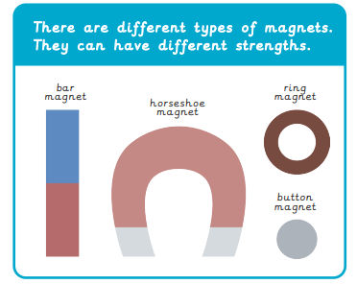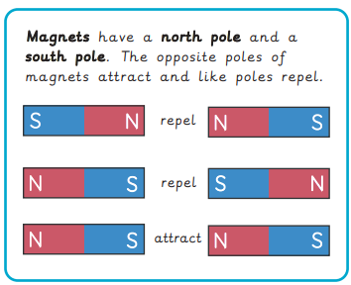

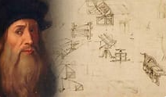

**Notable Scientist –** Leonardo da Vinci (1942 – 1519) spent more than 20 years studying friction in regards to various mechanical problems.

|  |  |  |  |
| --- | --- | --- | --- |
| **F:\Learning bugs\Foundation Subjects\Dolly the Fly - Science.jpgLyng Primary School Knowledge Organiser** | | | |
| **Topic: Forces and magnets** | **What are the effect and uses of forces and magnets?** | Year 3  Forces and magnets | Autumn 2 |

|  |  |  |  |
| --- | --- | --- | --- |
| 1. Which type of force acts at a distance? | **S** | | **E** |
| A contact force. |  |  | |
| Friction |  |  | |
| Magnet |  |  | |

|  |  |  |  |
| --- | --- | --- | --- |
| 5. Which of these is a magnetic material? | **S** | | **E** |
| Copper |  |  | |
| Iron |  |  | |
| Wood |  |  | |

|  |  |  |  |
| --- | --- | --- | --- |
| 1. Which surface will cause the most friction? | **S** | | **E** |
| Ice |  |  | |
| Tin foil |  |  | |
| Cotton |  |  | |
| Sugar paper |  |  | |

|  |
| --- |
| **True or false**? This pair of magnets will attract. |
| S - |
| E - |

|  |  |  |
| --- | --- | --- |
| 7. Which is an example of friction being unhelpful? | **S** | **E** |
| Wearing down bicycle tyres |  |  |
| Brushing your teeth |  |  |
| Lighting a match |  |  |

|  |  |  |  |
| --- | --- | --- | --- |
| 1. Which surface will cause the most friction? | **S** | | **E** |
| The rougher the surfaces, the more friction |  |  | |
| The rougher the surfaces, the less friction |  |  | |
| The smoother the surfaces, the less friction |  |  | |

|  |  |  |
| --- | --- | --- |
| 1. Which force comes from a magnet? | **S** | **E** |
| Friction |  |  |
| Gravity |  |  |
| Magnetism |  |  |

Start of quiz _________________

End of quiz ________________